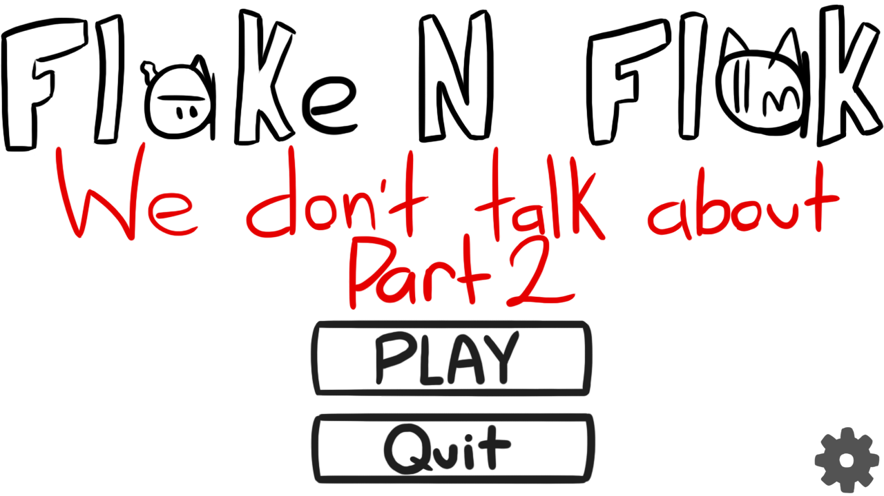

Flake N Flak

We don’t talk about Part 2

Brian Ramirez

Version: 1.0

Overview

Flake and Flak: We don’t talk about Part 2 is a story platformer game, where the user follows along on the quest to find and rescue flake.

Based upon an animated series I created, in part 1 Flake and Flak take off on a plane and end up crashing, following the crash is where We don’t talk about Part 2 begins.

The theme of the game follows upon the original flipnote art style of flake and flak, where everything is kept flat and 2D while the characters are able to defy logic in their movement and attacks.

Game Description

Objective -- In order to win the game you must defeat all enemies in all stages to progress to the final boss stage, where you must then rescue flake.

Gameplay -- You spawn on the first stage, where you see 2 enemies who are trying to attack you. You must evade their attacks and defeat them in order to go to the next stage. The second stage is very similar to the first except a bit harder, once again you must defeat the enemies to move on to the next stage. On the third stage there is only one enemy, however he is huge. Big enough that you cannot evade him, locked in scene3 with the enemy slowly approaching the user must find a way to defeat him (I RECOMMEND NOT READING THIS SO YOU DON’T SPOIL (highlight to read its in white font): after the enemy makes it past a certain point you are saved by an ally called nork). After defeating the enemy you meet an ally called nork, who decides to help you find flake. He lets you on his back and you are now able to attack with nork and flak and scene4 is unlocked. When you get to scene4 you see flake in a cage! There is a king in a chair, you then realize its a boss fight. He spawns his minions wave after wave in attempt to defeat you, the only way to stop him is by defeating him.

Controls -- A and D to move left and right, mouse1 to use flaks attack, mouse2 to use norks attack. E to interact when prompted. X to hop on norks back.

Assets Used

* Images

ay - drawn on photoshop cs6

ayflipped - drawn on photoshop cs6

bullet - drawn on photoshop cs6

evilangrycatface - drawn on photoshop cs6

evilangrycatfaceflipped - drawn on photoshop cs6

evilcatface - drawn on photoshop cs6

evilcatfacebrute - drawn on photoshop cs6

evilcatfaceflipped - drawn on photoshop cs6

evilcatfacegun - drawn on photoshop cs6

evilcatfacegunflipped - drawn on photoshop cs6

flak - drawn on photoshop cs6

flakandnork - drawn on photoshop cs6

flakandnorkflipped - drawn on photoshop cs6

flakattack1 - drawn on photoshop cs6

flakattack1flipped - drawn on photoshop cs6

flake - drawn on photoshop cs6

flaketextbox - drawn on photoshop cs6

flaketextbox2 - drawn on photoshop cs6

flakflipped - drawn on photoshop cs6

flakflippednobackground - drawn on photoshop cs6

flaknobackground - drawn on photoshop cs6

flakscared - drawn on photoshop cs6

flakscaredflipped - drawn on photoshop cs6

flaktextbox - drawn on photoshop cs6

flaktextbox2 - drawn on photoshop cs6

king - drawn on photoshop cs6

lives0 - took a screenshot in minecraft and removed background in photoshop cs6

lives1 - took a screenshot in minecraft and removed background in photoshop cs6

lives2 - took a screenshot in minecraft and removed background in photoshop cs6

lives3 - took a screenshot in minecraft and removed background in photoshop cs6

mainmenu - drawn on photoshop cs6

nork - drawn on photoshop cs6

norknotail - drawn on photoshop cs6

norktextbox - drawn on photoshop cs6

oldmainemnu - drawn on photoshop cs6

options - drawn on photoshop cs6

presse - drawn on photoshop cs6

scene1 - drawn on photoshop cs6

scene2 - drawn on photoshop cs6

scene3 - drawn on photoshop cs6

scene4 - drawn on photoshop cs6

scene4noking - drawn on photoshop cs6

throne - drawn on photoshop cs6

win - drawn on photoshop cs6

* Sound files

ay - voiced

bullet - voiced

click - https://www.youtube.com/watch?v=MCLYjgkiEpc

flakattack1 - voiced

hit - https://www.youtube.com/watch?v=bXDXOM7gK9M

imtheking - voiced

imtheking2 - voiced

legodeath - https://www.youtube.com/watch?v=2WWGVDR-7oM

minecrafthit - https://www.youtube.com/watch?v=lRp7QUL9z7s

sadmusic - https://www.youtube.com/watch?v=LCg2fZHpIBQ

sans - https://www.youtube.com/watch?v=F3nkoQ4crJ0

terraria - https://www.youtube.com/watch?v=DtKCNJmARF0

theme - https://www.youtube.com/watch?v=qxXSGKnBfaU

vineboom - https://www.youtube.com/watch?v=Oc7Cin_87H4

bossmusic - https://www.youtube.com/watch?v=Nf2dv-n4vww&t

dash - https://www.youtube.com/watch?v=FA41D9iWO80

lazer - https://www.youtube.com/watch?v=MuPl6RaLQyg

menu click - https://www.youtube.com/watch?v=MCLYjgkiEpc

punch - https://www.youtube.com/watch?v=iQLORgbwfJA

* Videos

intro - https://www.youtube.com/watch?v=TvPPBfSByt8

theme - https://www.youtube.com/watch?v=qxXSGKnBfaU&t

User Menu

Once the game is booted up you are greeted with a cutscene that is approximately 2 minutes. It is the first episode of Flake and Flak and gives brief context over the story of the game. If you click, you may skip it.

After the intro plays, you are greeted on a menu with 3 buttons. A button that says play, one that says quit, and a cog in the lower right hand corner. A video will also be playing, the Flake and Flak intro, It's basically menu music but with visualization if you would like. Upon clicking the cog, you are put on another menu which allows you to change settings and shows the user the controls. Currently you are only able to select between two difficulties: Hardcore and Ez. Hardcore is the default difficulty, where Ez will make the game significantly easier by reducing damage taken by 50% and multiplying your damage by 1.5x. To go back to the main menu you can click the “back” button at the lower left hand side. Once back on the menu the only other buttons are play and quit, quit will close the game, and play will begin it.

Upon starting the game you spawn on the left side of the screen as flak with a health value above you. On the lower left hand side it will display how many lives you have, starting with 3 by default. Once you run out of lives you are booted back to the menu. At the top of the screen there is a score, that score will go up every bit of damage you deal to any enemy. On the first stage, there are 2 enemies. One that moves and attacks in its radius and another that shoots from a distance. Only after defeating all enemies can you move on to the next stage. To move, A will make flak go left and D will make him go right. Space bar will allow flak to jump in which he can move in mid air. To attack press the left mouse button. Flak’s attack is a speech bubble of one of his sayings, its cooldown is entirely based on when it goes off screen, use this to your advantage by spamming attacks closer to the sides, it is risky but worthwhile.

After defeating all enemies you can move on to stage 2 by approaching the right hand side of the screen. Stage 2 is very similar to stage 1, upon moving on to stage 2 there are 3 enemies. Two that move on the ground and one on top of a market which shoots where you might jump. It is a wise decision to take care of the one on top of the market first so that you are free to jump without the risk of getting shot. The other 2 enemies will be attacking on the ground, one will be similar to the ground enemy from the first stage while the other is an angry variant. He does more damage, is faster, and has more health. DO NOT get hit by him at all costs, it is better to get hit by any other attack than his. After defeating all the enemies on the second stage you can now move on to the third stage.

The third stage is unique. There is only one enemy but he is massive. If you get hit by him you will likely lose all 3 of your lives instantly. You cannot jump over him, and it is impossible to kill him as he takes 1/20th of the damage that the player deals. Even in easy mode. Rather for this stage, you must simply wait until the enemy approaches you and stay on the left hand side and survive. This stage was made to give hope to the player to defeat the opponent. Sad and dramatic music plays as you are slowly backed into a corner. Just when the enemy is about to reach you, someone appears from the right hand side. A friend? A Foe? Without hesitation he kills the enemy with ease and saves you. You are now prompted to press E to interact with him, upon interaction you were able to recruit Nork to your cause. He tells you to mount onto him by pressing X. You can move on to stage 4 without mounting him, but it would be extremely unwise to do so. Mounting Nork makes you slower and you cannot jump as high as before, but you are now able to use Norks attacks by right clicking which do double flaks damage. In addition to unlocking Norks attack, flak can still attack by left clicking and since he is on top of Nork he can hit enemies that are higher up.

The fourth stage is the final boss stage. In the background you can see flake in a cage and a king in his throne (a recliner). He is the only enemy in sight until he yells “I’M THE KING!” and minions spawn from both sides. Two Angry enemies from the right, a normal ground enemy from the right, a gun enemy from the right aswell, and two more gun enemies on the left side. Nork is able to handle and attack the ground, but flaks attacks can no longer reach. Use Norks attacks to kill any ground enemies while trying to dodge the enemies attacks and chip the kings health down with flak. You may also jump and damage the king with norks attacks. If you manage to defeat the kings minions he will spawn more! The king is ruthless! The only way to defeat him and his minions is to take him down.

After defeating the king and any leftover minions, you can now interact with flake. Flake and flak briefly catch up and you have achieved the victory condition. Congratulations! This is a great feet.

Difficulties

The biggest difficulty for me was simply time management. From part 1 of the assignment I had only implemented a video and an image for a menu where the buttons did not work! I began working on part 2 of the assignment the day it was due and I spent nearly the entire day working to achieve the minimum requirements required. For part 2 of the assignment I made the menu buttons work and made flak spawn in with movement with the 4 stages with no backgrounds, no attacks, and no real purpose as of yet. However, this was a huge turning point for me. After implementing controls and completing a somewhat functional menu I was able to see the potential in what I could do. After that due date (wednesday) I worked for 4 days straight to achieve my submission. Thursday, Friday, Saturday, and Sunday. From the point I wake up until I go to sleep I would be working on my game.

Probably the biggest coding difficulty I had would be hitboxes. They were very janky and I spent a lot of time simply just testing on where I would get hit, the images I drew for the characters weren't exactly the dimensions of the entire image that the code would register so I really had to play with each individual hitbox to try and get it to a reasonable amount. I kept getting confused with the Y coordinate being a larger number the further down the screen you are as well.

The second biggest coding difficulty I had would be registering a “click”. At first, no matter what I seemed to do when I would click it would register multiple times causing me to click anything after a button or gui. The most simple solution that I used for quite a while was having buttons of the gui in different areas so that one click wouldn't activate the click directly after. This is why the cog and back buttons are in different corners. After this solution I left the issue as a later problem and continued working on my game. When I created cooldowns for attacks was when I found a solution! I could use the duration of a clicking sound as a cooldown. When you would click it would play a sound that lasted a second or two, and you could only click when that sound was not playing. Not the most practical solution but it's a solution!

Being able to google stuff helped out a ton with forgotten syntax.